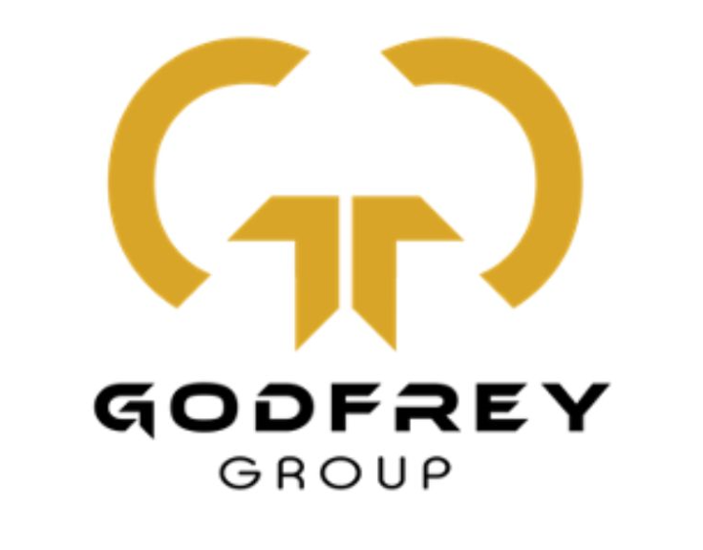

Godfrey Group

Modern Slavery and Human Trafficking Statement 2023 - 2024

Godfrey Group Facilities Ltd / Grwp Godfrey Cyfleusterau Cyf – About us

INTRODUCTION

Godfrey Group Facilities is an industry leader, offering unparalleled cleaning services to holiday parks, schools, offices, housing associations, popular venues and shopping centres, as well as building and maintenance services to housing associations, estates and private properties.

We provide efficiency, reliability and professionalism across all services. We apply innovative technology ensuring nothing gets side-lined, and progress is reported electronically. We deliver fairness and equality, a passion for the Welsh Language and Culture, respect for ideas and bespoke training for each employee, to the specifications of our sites.

Godfrey Group’s modern slavery and human trafficking statement
Here are the steps Godfrey Group has taken and continues to take to understand and minimise the potential risk of modern slavery in its business and supply chains. This statement is published in line with section 54(1) of the Modern Slavery Act 2015.

Our commitment to the principles of the Modern Slavery Act 2015
Godfrey Group is committed to the principles of the Modern Slavery Act 2015 and the abolition of modern slavery and human trafficking. As an equal opportunities employer, we're committed to creating and ensuring a non-discriminatory and respectful working environment for our staff. We want all our staff to feel confident that they can expose wrongdoing without any risk to themselves. Our recruitment and people management processes are designed to ensure that all prospective employees are legally entitled to work in the UK and to safeguard employees from any abuse or coercion. We do not enter into business with any organisation, in the UK or abroad, which knowingly supports or is found to be involved in slavery, servitude and forced or compulsory labour.

Our supply chain
Due to the nature of our business, we assess ourselves to have a low risk of modern slavery in our business and supply chains. Our supply chains are limited and we procure goods and services from a restricted range of UK and overseas suppliers.

Our policies in relation to the Modern Slavery Act 2015
The following policies are available to all staff:
- Code of conduct
- Ethics policy
- Whistleblowing policy
- Bullying and harassment policy
- Diversity and inclusion policy
- Recruitment and selection policy

Embedding the principles
We will continue to embed the principles through:
- providing awareness training to staff on the Modern Slavery Act 2015 and informing them of the appropriate action to take if they suspect a case of slavery or human trafficking
- ensuring staff involved in procurement activity are aware of and follow modern slavery procurement guidance on GOV.UK ensuring that consideration of the modern slavery risks and prevention are added to Godfrey Group’s policy review process
- ensuring that Godfrey Group’s contract terms and conditions include references to modern slavery and human trafficking
- continuing to take action to embed a zero tolerance policy towards modern slavery ensuring that staff involved in buying, procurement and the recruitment and deployment of workers receive training on modern slavery and ethical employment practices

This statement has been approved by Andrew Godfrey, Godfrey Group Director, for the financial year ending 31 March 2024. This statement will be reviewed and updated every year.

